** VELAMMAL BODHI CAMPUS**

**GRAND TEST - I - 2023-24**

**Class: 10 ENGLISH Marks:80**

**Date : 16.11.2023 Duration : 3:00 Hrs**

**I. READ THE FOLLOWING CAREFULLY AND ANSWER IT (10 MARKS)**

1. A youngster quit Facebook in December after spending over three years on the social networking site. With that one act, he bid a silent adieu to more than 300 contacts that he had added to his account during the period. Like almost everyone from his “friend’s circle,” the 20-year-old was a regular on the service; visiting it every day to post photos and status updates but last week a new feature on Facebook called Timeline forced him to reconsider the pros and cons of being on the networking site.
2. Everyone has some skeletons in their closet and I am just not comfortable with Facebook digging up and displaying all the facets of my life on a bulletin board,’ says this youngster who joined the network in July 2007, while he was in class 11th.
3. Facebook, you see, had compressed the time he spent on the site and arranged it in chronological order. While he initially liked the new neatly organized scrapbook-like feature he wasn’t happy to reveal posts from the past that until recently were hidden under layers and layers of recent updates. Just clicking on a date on the timeline could transport his friends back in time and enable them to view every embarrassing comment link or photo he had posted on his profile.
4. “I think it’s a recipe for disaster,” he says. “In 2007, I had some wall posts which seemed appropriate at the time but now after a lapse of four years, I have moved on and don’t want them to be openly displayed for all to see.”
5. He is not alone. Many users, worried about how the Facebook activity could possibly affect their offline lives, are choosing to commit “Facebook suicide.” While some have privacy concerns, others feel that the site meant to bring them closer to their friends actually does the opposite- it reduces their friendship to something superficial.
6. Poking and liking are not enough to keep a friendship going,’ says a business analyst. Having quit Facebook three years ago, she prefers meeting her “real” friends face-to-face, instead of reading their trite posts online. “On Facebook, people hype everyday issues including what they ate and where they went on a daily basis,” says this analyst who continues to use Twitter.
7. “Facebook has become a time sink and it could not justify the time I spent on it,” he says, “I spend more time calling up friends or relatives over the phone now I also go out and meet people whenever possible and have a good offline life. I do not regret the change.” Today, Facebook has 800 million users of which 37 million are Indians. The site has become an online identity for most, and many of those who decided to quit cannot overcome the withdrawal symptoms and return. Facebook, fully aware of its addictive powers, facilitates this return by allowing users to ‘deactivate’ their accounts but continues to store information on its servers so that they can return from their ‘break’, whenever they wish.

**ANSWER THE FOLLOWING QUESTIONS, BASED ON THE PASSAGE ABOVE.**

* 1. Which of the following statements best describes the reason for the youngster’s reaction to the posts he made in the past? 1

a. He did not want to the reminded of the past. b. He was reminded of the bitter past.

c. He felt it unnecessary. d. He was embarrassed of the post.

* 1. Based on your reading of the text, list any two disadvantages of the social media site Facebook. 2
  2. Complete the sentence appropriately. 1

People are choosing to commit Facebook suicide because .......... .

* 1. The passage includes some words that are opposites of each other. From the sets (a)-(e) below, identify a set of antonyms. 1
     1. Pros and disaster
     2. Superficial and real
     3. Quit and regular
     4. Addictive and lapse
     5. Facilitates and updates
  2. Complete the sentence appropriately. 1

According to the author, feature of Timeline takes away a person’s privacy.

* 1. Why did the youngster change his mind later regarding staying on Facebook 2
  2. Evaluate the appropriate characteristic that can be apt for the lives of people who had quit Facebook. 1

a. Embarrassing and Addictive b. Sad and Hysterical

c. Social and Real d. Nostalgic and Fear of missing out

* 1. In Paragraph 7, the author says ‘allowing users to ‘deactivate’ their accounts but continues to store information on their servers so that they can return from their ‘break’, whenever they wish.’ 1

State the reason for doing so by Facebook.

## **2. READ THE FOLLOWING PARAGRAPH CAREFULLY AND ANSWER IT (10 MARKS)**

1. Tourism, for millennia, has been a perpetual industry. Though initially unorganised and highly chaotic, it retained a place in each nook of history. The present tourism scenario in India is on the rise, with destinations grabbing eyeballs globally and domestically. Being the youngest nation in the world, it’s no wonder that the aggregate of ‘millennials’ spends more time and money on travel than previous generations. This could be huge for the economy of various states that rely majorly on tourism, if only it were sustainable.
2. Unsustainability prevails throughout the country, in states with higher domestic tourist inflow than foreign. The Dev Bhoomi is a prime example. NO matter how popular, Uttarakhand tourism is loop- holed through and through.
3. Approx. 80% of tourists arrive to complete the infrastructure of the Dham Yatra. Such unchecked tourism puts immense pressure on natural and infrastructure facilities. The extreme shortage of accommodation in correspondence with thriving footfalls has led to the construction of illegal buildings, the majority of which exist on riverbanks. With an increasing number of tourists coming in through private vehicles to save “transportation money”, pollution levels are rising, increasing temperatures in return. With unlawful construction and pollution on riverbanks, the Ganges could cause direct harm to local species in Rishikesh and Haridwar.
4. Around 10,000 hilly areas are being convened for the construction of roads alone. We know roads are basic infrastructure but the Forest Conservation Act requires a project developer to plant trees in a non- forest/degraded forest area equal to or twice the trees, it’s clearing respectively, to compensate which does not happen.
5. The India State of Forest Report illustrates how Uttarakhand is losing its forest cover, which has indirect development through tourism, at its core. The government and private tour operators may think they can deny allegations but the charts speak for themselves.
6. We, as consumers of the tourism industry, hold the power to cause a massive stir in this context. According to research conducted, Uttarakhand’s mass tourism comprises people between 25-35 years of age, with higher education, out with either family or friends and enough average income to contribute to the local economy.
7. Regardless of what the figures say, if we look forward to sustainable tourism being the target market, it leaves little choice to the rest of the hierarchy.

Consciously making efforts to be responsible tourists and thinking of how to provide for the local community/environment in a way - tiny or big, could act as a catalyst in obliterating this ruckus due to ignorance. After all, there can only ever be seven deadly sins and wanderlust isn’t one of them.

**ANSWER THE FOLLOWING QUESTIONS, BASED ON THE PASSAGE ABOVE.**

* 1. Complete the following sentence appropriately. 1

According to the passage, wanderlust is equated to reach the level of the seven deadly sins because

..........

* 1. Fill in the blanks with the appropriate option from those given in brackets. 1

From paragraph 1 we can infer that (illegal construction/unchecked tourism) is the main cause for putting pressure on infrastructural and natural resources.

* 1. Justify the following, in about 40 words. 2

We, as consumers of the tourism industry, hold the power to cause a massive stir.

* 1. How does the unchecked tourism in Uttarakhand affect the natural landscape? 1
  2. Unsustainability prevails in Dev Bhoomi. List any two reasons for the same. 1
  3. According to the passage, select the chart that is the correct depiction of the relation between incoming tourists and the temperature of the region. 1

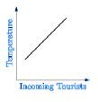 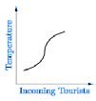 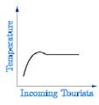

(1) (2) (3)

* + 1. Chart 1
    2. Chart 2
    3. Chart 3
    4. None of these
  1. Infer one consequence, based on your understanding of the passage, that highlights the result of the pressures of a large number of tourists. 2
  2. What do the tourist statistics show in the region of Uttarakhand? 1
     1. Domestic footfall is equal to international footfall.
     2. Domestic footfall is less than international footfall.
     3. Domestic footfall is limited to certain seasons.
     4. Domestic footfall is greater than international footfall.

# **SECTION B - GRAMMAR & WRITING SKILLS 20**

# **GRAMMAR**

## Complete **ANY TEN** of twelve of the following tasks, as directed. **10 X 1=10**

* 1. Fill in the blank by choosing the correct option to complete the sentence. 1

If only he us truth in the first place, things would not have gone wrong.

a. has told b. would have told c, had told d. should have told

* 1. Read the conversation between Prateek and Raghav. and complete the narration that follows. 1

Prateek: I don’t feel well today.

Raghav: What can I help you, Sir? Prateek: Can you take me to the doctor? Raghav: Yes, Sir.

Prateek told Raghav that he did not feel well that day. Raghav asked respectfully what he could help him. Prateek asked Raghav Prateek replied in the affirmative.

* 1. Select the correct option to fill in the blank for the given line. 1

If I dyed my hair green, everybody laugh at me.

* + 1. would
    2. should
    3. may
    4. can
  1. Select the option identifies the error and supplies the correction for the following line : 1

As far as climate change is concerned, South Asia is one of a world’s most sensitive areas.

|  |  |  |
| --- | --- | --- |
| **Option No.** | **Error** | **Correction** |
| (a) | change | changes |
| (b) | is | was |
| (c) | most | many |
| (d) | a | the |

* 1. Complete the given sentence, by filling in the blank with the correct option : 1

As he was crossing the road, a car him down.

* + 1. was knocking
    2. had knocked
    3. knocked
    4. would have knocked
  1. Fill in the blank by using the correct form of the word in the bracket. 1

The woman in the pool (swim) well.

* 1. Report the dialogue between Mannu and Annu, by completing the narration : 1

Mannu: Where are you going to?

Annu: I am going to the market. Do you want anything?

Mannu asked Annu where she was going. Annu replied that she was going to the market and she further asked .

* 1. Identify the error in the given sentence and supply the correction. 1

I met her by chance then I gone to get some Medicine which Sister Amy used to give.

Use the given format for your response.

|  |  |
| --- | --- |
| **ERROR** | **CORRECTION** |
|  |  |

* 1. Transform the following direct speech into reported speech : 1

I said to him, “Where have you lost the pen I brought for you yesterday ?

* 1. Identify the error in the given sentence and supply the correction. 1

I remember my promise, I would help you in the hour of your need. Use the given format for your response.

|  |  |
| --- | --- |
| **ERROR** | **CORRECTION** |
|  |  |

* 1. Select the correct option to complete the narration of the dialogue between a teacher and a student. 1 Biology Teacher : I instructed you to draw the diagram of bacteria. Why did you submit a blank sheet? Sameer : Sir, I had drawn the diagram of bacteria, but you can’t see it because it is not visible to the naked eye.

The biology teacher had instructed Sameer to draw the diagram of a bacterial cell and asked him why he had submitted a blank sheet. Sameer respectfully answered that he had drawn the diagram but

* + 1. he can’t see it because it is not visible to the naked eye.
    2. he couldn’t see it because it is not visible to the naked eye.
    3. he could see it because it is visible to the naked eye.
    4. he could not be seen it because it is not visible to the naked eye
  1. Identify the error in the given sentence and supply the correction 1

There are a little countries in the world where the population is not growing fast. Use the given format for your response.

|  |  |
| --- | --- |
| **ERROR** | **CORRECTION** |
|  |  |

**SECTION – B (WRITING)**

4. A. **Write a letter to the Municipal Commissioner** bringing the problem of insanitary conditions in your colony to his notice and request him to take urgent action in the matter. You are Rahim / Shailu living in Nehru Street, New Delhi.

**OR**

B. You are Apoorva/Arpit. You bought a refrigerator from Ganesh Electronics and Electricals, Gandhi Marg, Nagpur. It does not function properly. **Write a letter to the Sales Manager** of the shop, complaining about the defect and asking for immediate replacement or repair, as necessary. **(5 MARKS)**

## 5. A. Given below is a newspaper report on the state of cancer prevailing in India. You have been asked to **write an analytical paragraph** on ‘Cancer - a silent killer’ Taking information from the clipping given below together with your own ideas, write this paragraph in 100-120 words.

“In India, cities are more cancer-prone than rural areas. In the early 1990’s, we expected one out of 10- 15 urban Indians to get cancer in their life -time, that is every second or third family would have to face this disease. This is partly due to high levels of benzene in the air and also that the metros are exposed to high levels of pesticides in their foods. In order to check the steady growth of cancer in the country, the Government shall have to give priority to preventive action. At the same time measures to undertake improvement in facilities for the treatment of cancer shall have to be adopted.”

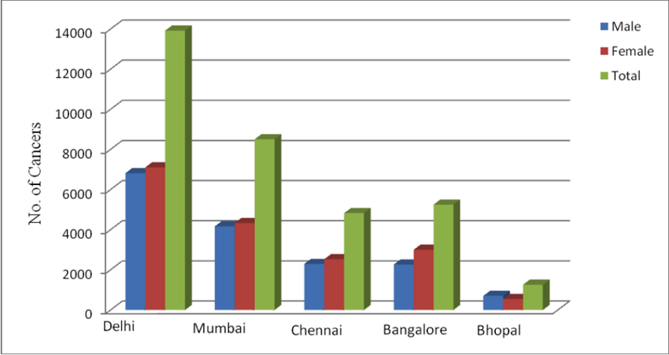

(**OR)**

B. The maps below show the village of Stoke ford in 1930 and 2010. Write an analytical paragraph in 100- 120 words by selecting and reporting the main features, and making comparisons where relevant.

**(5 MARKS)**

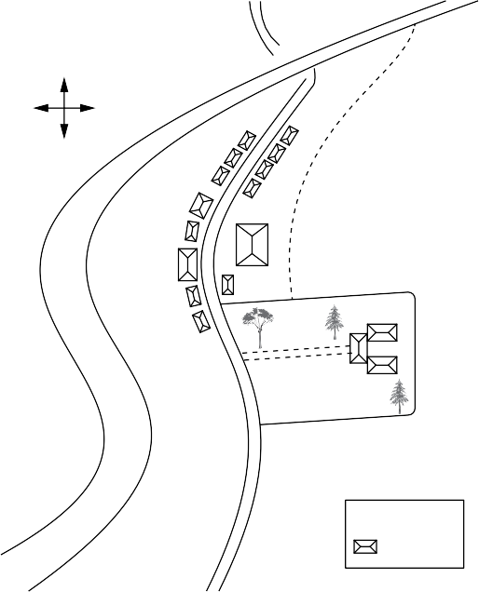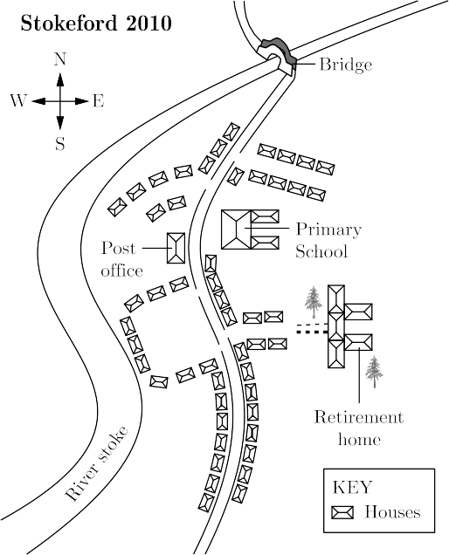

(A) (B)

**SECTION – C (LANGUAGE AND LITERATURE)**

**6. READ THE FOLLOWING EXTRACT CAREFULLY AND ANSWER IT (5 MARKS)**

**A.** I was not born with a hunger to be free, I was born free – free in every way that I could know. Free to run in the fields near my mother’s hut free to swim in the clear stream that ran through my village, free to roast mealies under the stars and ride the board backs of slow – moving bulls. As long as I obeyed my father and abided by the custos of my tribe, I was not troubled by the laws of man or God. It was only when I began to learn that my boyhood freedom was an illusion, when I discovered as a young man that my freedom had already been taken from e, that I began to hunger for it.

**(i) Author initially thought that**

a. he was not born with a hunger to be free b. he was born free

c. either (a) or (b) d. both (a) and (b)

**(ii) The author was free to which of the following activities**

1. run in the fields near his mother’s hut 2. free to swim in the clear stream

3. disobey his father 4. Roast his mealies 5. Play with white people

a. 1,2 and 3 b. 2,3 and 4 c. 3,4 and 5 d. 4,1 and 2

**(iii) which of the following restriction author had during his childhood**

a. obey his father b. obey his mother

c. follow customs of his tribe d. both (a) and (c)

**(iv) Based on the extract please classify following as fact and opinion**

1. author was free to swim in clear swim

2. Author must have been a notorious boy during his childhood

3. author later realized that his boyhood freedom was an illusion

4. author, as a young man, began to hunger for freedom

a. F 1,2 and O – 3,4 b. F 1,3 and O – 2,4 c. F 1,4 and O – 2,3 d. F 2,4 and O – 1,3

**(v) An expression ‘as long as I obeyed my father’ has been used in the extract. Which of the following is not the correct similar expression.**

a. as long as I respected my principal b. as long as he stayed in my house

c. as long as I studying science d. as long as used pencil

**(OR)**

**B.** If strolling forth, a beast you view,  
Whose hide with spots is peppered,  
As soon as he has lept on you,  
You’ll know it is the Leopard.  
’Twill do no good to roar with pain,  
He’ll only lep and lep again.

**i. Given below are four examples of activities that Jasmeet does. Choose the option that correctly demonstrates ‘strolling’.**

a. Jasmeet runs with great speed after being chased by a dog.

b. Jasmeet walks in the garden, relaxing while listening to his favorite song.

c. Jasmeet skids sharply on the ice skate rink.

d. Jasmeet rushes to switch off the water pump in the backyard.

**ii. The repetition used in “he’ll only lep and lep again” is an example of**

a. poetic justice. b. Satire c. allusion. d. poetic license.

**iii. Choose the option listing the stanza that would follow the given extract.**

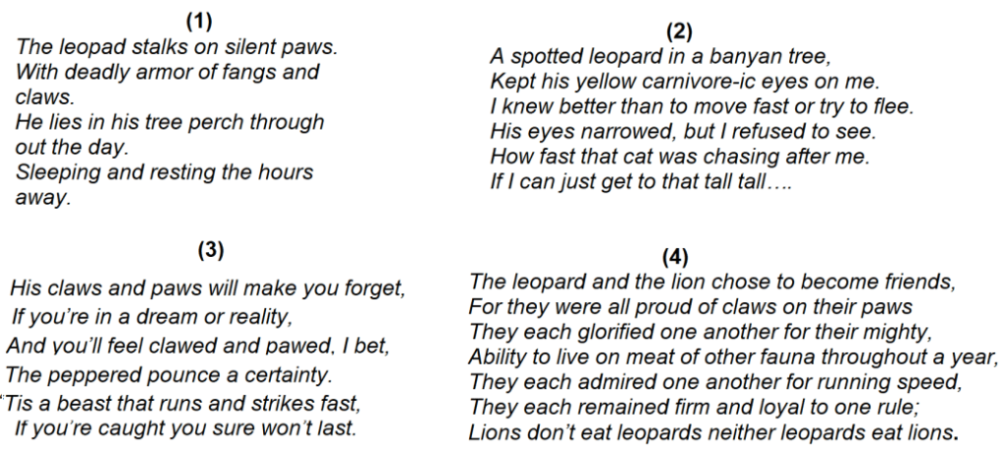

**a. Option 1** **b. Option 2** **c. Option 3** **d. Option 4**

**iv. Which option lists the statement that is NOT TRUE according to the extract?**

a. The poet asks the reader to hide on seeing the leopard.

b. The poet cautions the reader about a leopard when walking through its territory.

c. The poet informs the reader that a leopard can launch repeated attacks.

d. The poet tells the reader that a leopard attack can result in pain.

**v. Choose the option that matches the rhyme scheme of the extract.**

|  |  |  |  |
| --- | --- | --- | --- |
| **1. Proud Loud Child Wild Jungle Mingle** | **2. Wild Jungle Child Mingle Loud Proud** | **3. Wild Proud Child Loud Jungle Mingle** | **4. Loud Jungle Wild Child Mingle proud** |

**a. option 1 b. option 2 c. option 3 d. option 4**

**7.** **READ THE FOLLOWING EXTRACT CAREFULLY AND ANSWER IT (5 MARKS)**

**A.** “I didn’t get any real results,” he said. “But I went ahead and showed that I had tried the experiment. This time I won.” The next year his science fair project was testing the theory that viceroy butterflies copy monarchs. The theory was that viceroys look like monarchs because monarchs don’t taste good to birds. Viceroys, on the other hand, do taste good to birds. So, the more they look like monarchs, the less likely they are to become a bird’s dinner. Ebright’s project was to see whether, in fact, birds would eat monarchs. He found that a starling would not eat ordinary bird food. It would eat all the monarchs it could get.

**i. Choose the option listing Ebright’s qualities as depicted by the above extract.**

1. persevering 2. Visionary 3. Determined 4. Liberal 5. conceited

a. 1, 2 b. 3, 5 c. 1, 3 d. 4, 5

**ii. According to the dictionary, ‘fair’ as a noun, shows the following meanings.**

**Choose the option that lists the meaning similar to the usage to that in the extract.**

**a.** A gathering of stalls and amusements for public entertainment.

b. A competitive exhibition showcasing products or ideas.

c. A periodic gathering for the sale of goods.

d. An annual exhibition of livestock, agricultural products, etc., held by a town, county, or state.

**iii. Choose the option that is true for the two statements given about the information in the extract.**

* **Statement 1- Starling feeds on viceroys.**
* **Statement 2- Starling does not eat seeds and insects.**

a. Both statements are clearly mentioned in the extract.

b. Statement 1 cannot be clearly inferred from the text and statement 2 is true.

c. Statement 1 is false and statement 2 cannot be clearly inferred from the extract.

d. Both statements need to be inferred from the given extract.

**iv. Choose the statements that are TRUE for the given extract contextually.**

1. Ebright didn’t get any results for the experiment he conducted on butterflies.
2. Monarchs tasted awful to the birds.
3. Ebright wanted to explore the possibility of monarchs getting eaten by birds.
4. He wanted to prove that viceroys were lookalikes of monarchs.

a. 1, 2 b. 2, 3 c. 1, 3 d. 2, 4

**v. Four friends bring their pets to a pet show. Choose the option that mentions the friend with a starling as a pet.**

|  |
| --- |
| **Friend 1 has a turtle named Missy.** |
| **Friend 2 has a dragonfly named Majesty.** |
| **Friend 3 has a rabbit named Molly.** |
| **Friend 4 has a bird named Mitch.** |

**a. Friend 1 b. Friend 2 c. Friend 3 d. Friend 4**

**(OR)**

**B.** I think he knew I made a little money this way but he did not seem to mind. Anil made money by fits and starts. He would borrow one week, and lend the next. He kept worrying about his next cheque, but as soon as it arrived, he would go out and celebrate. It seems he wrote for magazines—a queer way to make a living!

**i. Anil made money ‘by fits and starts’ means that he**

**a. deemed it fit to start investing money. b. started earning money in the recent past.**

**c. received money intermittently. d. put his money to use frequently.**

**ii. The information in the extract suggests that Anil could be a**

**a. salaried professional b. freelancer c. businessman d. volunteer**

**iii. If borrow: : lend, then pick the ODD pair from the options below**

**a. give: : take b. lose: : find c. hop: : skip d. buy: : sell**

**iv. The reference to making a little money ‘this way’ refers to a way that is viewed by most people as**

**a. sensible. b. inappropriate. c. charitable. d. Aggressive**

**v. Based on your understanding of Anil in the extract, choose the option that synchronizes with his thinking.**

**a. So what if I don’t have much money? Giving it to that person is important as they could do with a helping hand.**

**b. I better learn how to protect my money. I think I’m being looted.**

**c. I earn money with such tremendous effort. Where does it all go?**

**d. When I become rich, I can begin to help friends then. Right now, I will spend only on myself.**

**8. Answer ANY FOUR of the questions out of five questions (4x3=12)**

**a.** Validate the given statement with reference to the baby seagull’s fear.

‘Fear doesn’t exist anywhere else other than one’s mind.’

**b. How did the baker become synonymous with celebrations and occasions in Goa?**

**c.**  If you were to advise Valli on the two things she ought to take with her if she were traveling alone for the first time, what would they be and why?

**d. In the poem “The Trees”, the poet compares the trees to “newly discharged patients”. Highlight any two reasons for the same.**

**e.** **A popular quote states:**Responsibility is self-taught**. How does the poem “The Ball Poem” address this thought?**

**9 Answer ANY TWO of the questions out of three questions (2x3=6)**

**a.** **The neighbours suspected Griffin of burglary. State why this was OR was not justified.**

**b.**  **“A Question of Trust” is a story about the robbery of the robber. Expound.**

**c.** Why was it important for Mrs. Pumphrey to be a little cruel in order to be kind towards Tricki?

**10. Answer ANY ONE of the questions out of two questions (1x6=6)**

**A. “Not from weeping nor from grieving will anyone obtain peace of mind’.**

**If you had to use the message of the given quote from the Buddha’s sermon (The Sermon at Benares) to help the boy cope with the loss of his ball and what it signifies (The Ball Poem), what would you include in your advice?**

**Also, evaluate why it might be difficult for him to understand the notion.**

**(OR)**

**B.** Anne was a sensitive and mature girl. From the chapters and poems in your textbook, First Flight, think of any two characters who could be her friends or confidantes.

Analyze the common character traits that would help in creating this special bond of friendship.

**11. Answer ANY ONE of the questions out of two questions (1x6=6)**

**A.** **As the woman who dupes Danby, pen a diary entry for the night before the robbery.**

**Pen down your thoughts, fears, and hopes from the robbery based on the events of the story "The Question**

**of Trust".**

**Wednesday, 12 July '78 9 PM**

**Its D-day, finally! Today, I know how it feels to be nervous and excited at the same time……. (continue)……….**

**(OR)**

**B. Imagine you are Richard. You have been invited by Mr. Weiherer to deliver a short address to the students at your erstwhile school. You have been asked to encourage them to take an interest in the study of Science and how research in Science can help the world. Write that short speech.**

**Good morning, students.**

It is an honor to be back at my erstwhile school. I have many………………………..**(continue)……….**